Codebook for Beer_and_Brewery

Autogenerated data summary from dataMaid

**Description:**

This dataset is a merge of the Beers dataset which contains a list of 2410 US craft beers and the Breweries dataset which contains 558 US breweries.

**Beers.csv:**

* Name: Name of the beer.
* Beer_ID: Unique identifier of the beer.
* ABV: Alcohol by volume of the beer.
* IBU: International Bitterness Units of the beer.
* Brewery_ID: Brewery id associated with the beer.
* Style: Style of the beer.
* Ounces: Ounces of beer.

**Breweries.csv:**

* Brew_ID: Unique identifier of the brewery.
* Name: Name of the brewery.
* City: City where the brewery is located.
* State: U.S. State where the brewery is located.

# Data report overview for Beer_and_Brewery

The dataset examined has the following dimensions:

|  |  |
| --- | --- |
| Feature | Result |
| Number of observations | 2410 |
| Number of variables | 10 |

# 

# Codebook summary table

|  |  |  |  |  |  |
| --- | --- | --- | --- | --- | --- |
| Label | Variable | Class | # unique values | Missing | Description |
|  | **Brewery_id** | integer | 558 | 0.00 % |  |
|  | **Beer** | character | 2305 | 0.00 % |  |
|  | **Beer_ID** | integer | 2410 | 0.00 % |  |
|  | **ABV** | numeric | 75 | 2.57 % |  |
|  | **IBU** | integer | 108 | 41.70 % |  |
|  | **Style** | character | 100 | 0.00 % |  |
|  | **Ounces** | factor | 7 | 0.00 % |  |
|  | **Brewery** | character | 551 | 0.00 % |  |
|  | **City** | character | 384 | 0.00 % |  |
|  | **State** | character | 51 | 0.00 % |  |

# Variable list

## Brewery_id

|  |  |
| --- | --- |
| Feature | Result |
| Variable type | integer |
| Number of missing obs. | 0 (0 %) |
| Number of unique values | 558 |

## Beer

|  |  |
| --- | --- |
| Feature | Result |
| Variable type | character |
| Number of missing obs. | 0 (0 %) |
| Number of unique values | 2305 |
| Mode | “Nonstop Hef Hop” |

## Beer_ID

|  |  |
| --- | --- |
| Feature | Result |
| Variable type | integer |
| Number of missing obs. | 0 (0 %) |
| Number of unique values | 2410 |

## ABV

|  |  |
| --- | --- |
| Feature | Result |
| Variable type | numeric |
| Number of missing obs. | 62 (2.57 %) |
| Number of unique values | 74 |
| Median | 0.06 |
| 1st and 3rd quartiles | 0.05; 0.07 |
| Min. and max. | 0; 0.13 |

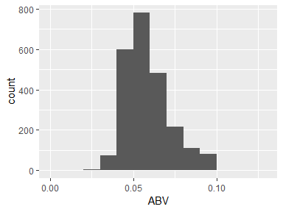

## IBU

|  |  |
| --- | --- |
| Feature | Result |
| Variable type | integer |
| Number of missing obs. | 1005 (41.7 %) |
| Number of unique values | 107 |
| Median | 35 |
| 1st and 3rd quartiles | 21; 64 |
| Min. and max. | 4; 138 |

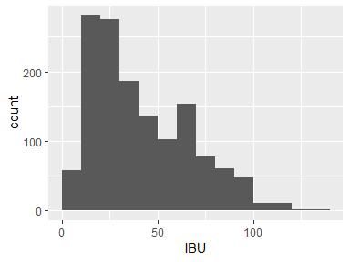

## Style

|  |  |
| --- | --- |
| Feature | Result |
| Variable type | character |
| Number of missing obs. | 0 (0 %) |
| Number of unique values | 100 |
| Mode | “American IPA” |

## Ounces

|  |  |
| --- | --- |
| Feature | Result |
| Variable type | factor |
| Number of missing obs. | 0 (0 %) |
| Number of unique values | 7 |
| Mode | “12” |
| Reference category | 12 |

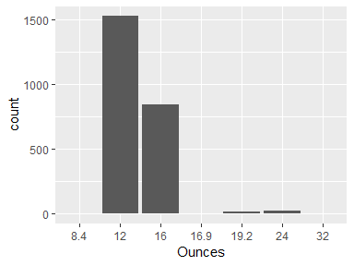

* Observed factor levels: "12", "16", "16.9", "19.2", "24", "32", "8.4".

## Brewery

|  |  |
| --- | --- |
| Feature | Result |
| Variable type | character |
| Number of missing obs. | 0 (0 %) |
| Number of unique values | 551 |
| Mode | “Brewery Vivant” |

## City

|  |  |
| --- | --- |
| Feature | Result |
| Variable type | character |
| Number of missing obs. | 0 (0 %) |
| Number of unique values | 384 |
| Mode | “Grand Rapids” |

## State

|  |  |
| --- | --- |
| Feature | Result |
| Variable type | character |
| Number of missing obs. | 0 (0 %) |
| Number of unique values | 51 |
| Mode | “CO” |

Report generation information:

* Created by Jasmine Coleman.
* Report creation time: Sat Mar 02 2019 15:00:03
* dataMaid v1.2.0 [Pkg: 2018-10-03 from CRAN (R 3.5.2)]
* R version 3.5.2 (2018-12-20).
* Function call: makeDataReport(data = Beer_and_Brewery, mode = c("summarize", "visualize", "check"), smartNum = FALSE, file = "codebook_Beer_and_Brewery.Rmd", checks = list(character = "showAllFactorLevels", factor = "showAllFactorLevels", labelled = "showAllFactorLevels", haven_labelled = "showAllFactorLevels", numeric = NULL, integer = NULL, logical = NULL, Date = NULL), listChecks = FALSE, maxProbVals = Inf, codebook = TRUE, reportTitle = "Codebook for Beer_and_Brewery")